Master has following protection

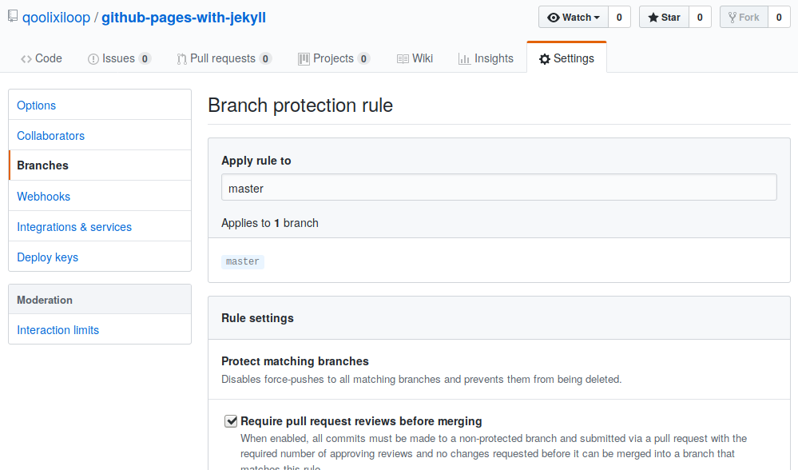

Move the most recent commit(s) to a new branch with Git
Ask Question

4045
I'd like to move the last several commits I've committed to master to a new branch and take master back to before those commits were made. Unfortunately, my Git-fu is not strong enough yet, any help?
I.e. How can I go from this
master A - B - C - D - E
to this?
newbranch C - D - E
/
master A - B

Moving to a new branch
WARNING: This method works because you are creating a new branch with the first command: git branch newbranch. If you want to move commits to an existing branch you need to merge your changes into the existing branch before executing git reset --hard HEAD~3 (see Moving to an existing branch below). If you don't merge your changes first, they will be lost.
Unless there are other circumstances involved, this can be easily done by branching and rolling back.
# Note: Any changes not committed will be lost.
git branch newbranch # Create a new branch, saving the desired commits
git reset --hard HEAD~3 # Move master back by 3 commits (GONE from master)
git checkout newbranch # Go to the new branch that still has the desired commits
But do make sure how many commits to go back. Alternatively, you can instead of HEAD~3, simply provide the hash of the commit (or the reference like origin/master) you want to "revert back to" on the master (/current) branch, e.g:
git reset --hard a1b2c3d4
*1 You will only be "losing" commits from the master branch, but don't worry, you'll have those commits in newbranch!
WARNING: With Git version 2.0 and later, if you later git rebase the new branch upon the original (master) branch, you may need an explicit --no-fork-point option during the rebase to avoid losing the carried-over commits. Having branch.autosetuprebase always set makes this more likely. See John Mellor's answer for details.

Moving to an existing branch
If you want to move your commits to an existing branch, it will look like this:
git checkout existingbranch
git merge master
git checkout master
git reset --hard HEAD~3 # Go back 3 commits. You *will* lose uncommitted work.
git checkout existingbranch

